Science Building User’s Guide

I Office facilities 2
1 Curtain measurement; room area measurement; screen window measurement and installation 2
2 Installation and dial instruction of fixed-line telephone 3
3 Facilities repair and contact with property management office 4
4 Room air purification treatment 5
5 Replacement of inner film of air purifier 5
6 Electricity safety of office 5
II Furniture power supply, network, telephone wiring arrangements in teachers’ office 6
III Administrative services and seal use procedures 6
1 Administrative services 6
2 Procedures for using “seal of School of Mathematical Sciences” 8
IV Discussion room and conference room 10
1Online reservation of conference room and discussion room 10
2 Cleaning of discussion room and conference room 11
3 Mobile projection in discussion room 12
V Visiting scholar office 14
1 Reservation of visiting scholar office 15
2 Office supplies for visiting scholars 16
VI School public printing facilities 16

Since not all basic facilities have been installed after we moved into the Science Building, we would like to bring to the attention of all the teachers the following issues.

I Office facilities

1 Curtain measurement; room area measurement; screen window measurement and installation
All the curtains have been installed so far. For purpose of environmental protection, the curtains have been sent to cleaning plant on 23 May for washing, drying and ironing. And the curtains will be put up again on 6 June. The School will designate people to monitor the installation process, but we still advice all the teachers to safeguard your valuables in case of loss. (Contact: Pan Gu; campus contact number: 622107; gupan@sjtu.edu.cn)
The School has already arranged the plant to measure the window area of each teacher office on 28 May. It will probably take two weeks for screen window customization and installation. The plant promised that the screen windows of all the teacher’ offices will be installed by 15 June. The School will designate people to monitor the installation process, but we still advice all the teachers to safeguard your valuables in case of loss. (Contact: Pan Gu; campus contact number: 622107; gupan@sjtu.edu.cn)

2 Installation and dial instruction of fixed-line telephone

All the telephones have been installed. Fixed-line telephone number of each teacher office may be found on personal homepage of the teacher and the address book of the School’s information system. For installation related questions, please contact Pan Gu (campus contact number: 622107; gupan@sjtu.edu.cn). For fixed-line telephone numbers of the School’s Administration Office, Education Administration Office, laboratory and library reference room, please visit http://www.math.sjtu.edu.cn/about/show4-2.php
Telephone dialing methods: dial in from outside school, dial telephone number directly; dial outside number from school, add "9" before the number that needs to be dialed; dial Minhang Campus telephone number, you need to dial " 8 plus 8 digit telephone number"; dial Xuhui Campus telephone number, you dial " 6 plus the last 4 number of 8 telephone number"; dial Qibao Campus telephone number, you dial" 7 plus the last 4 number of 8 telephone number".

3 Facilities repair and contact with property management office
As the Science Building has not been handed to the property, building facilities still need maintenance. If you encounter any inconvenience, you may declare through the school OA system. (http://www.math.sjtu.edu.cn/rsv.php) if any facility in the building requires repair. When contact information of the property management office of the Building is available, the School will publicize the fixed-line
telephone number of property management office and the teachers may contact the office for facility repair issues. (Contact: Ms.Hua 13917006679; manager Zhou of property management company 13341806995; manager Zhang of property management 13341806968)

4 Room air purification treatment
Furniture of all the teacher offices has been installed. Air purification company will conduct the third round of air purification treatment on June 8-10. Please stay in the office, or properly keep your valuables, entrust other colleagues to help look after the office during this period. (Contact: Limin Qin; campus contact number:622017; qinlimin@sjtu.edu.cn)

5 Replacement of inner film of air purifier
As required, inner films of the first batch of air purifiers which have already been put into use have to be replaced by the end of May after three months of use. Please contact Limin Qin for the matter (campus contact number: 622017，qinlimin@ sjtu.edu.cn). New purification film will be replaced on 10 June.

6 Electricity safety of office
Security warning in the school office as follows: no overload electrical appliances, no private wires, no illegal appliances, no series multiple line board, etc. Please replace the aging wires/electrical appliances in time and electric equipment should plug off after using. Please shut down electric equipment when you leave the office, such as air conditioner, air purifier, computer power supply, etc. (Contact person: Jiajun Zhu, campus contact number: 622014, zhu_jiajun@sjtu.edu.cn)

II Furniture power supply, network, telephone wiring arrangements in teachers’ office
After the installation of the new furniture, teachers have put forward many demands for wiring in recent days, our institute will focus on the wiring project. Please pay attention to the following matters while submitting the wiring application:
1、Please take good care of the board, cable port and screws in the desk slot to avoid unnecessary accessories loss;
2 、It will be inconvenient for changing furniture positions after wiring being arranged, therefore please confirm position of furniture carefully in the right place;
3、By default, wiring shall be treated as open wire (i.e. wire groove shall be made along the wall);
4 、Please remark the wiring time when submitting the application. We will conduct wiring in weekly batches. Please take good care of your personal valuables during wiring construction. (Contact person: Xiaotong Jiang, campus contact number: 62230, fate772yy@sjtu.edu.cn)

III Administrative services and seal use procedures

1 Administrative services
1 、To apply for parking voucher for official car and visitor’s car, please first submit application on https://jinshuju.net/f/a3QIFk, and then go to the Administration Office (712) to receive the voucher from Hengmin Xu. (campus contact number: 62212, hmxu@sjtu.edu.cn）
2、To apply for office supplies, please first submit application on https://jinshuju.net/f/CQRwfU and then go to Room 712 to receive the office supplies from Hengmin Xu. (campus contact number:62212, hmxu@sjtu.edu.cn）
3 、Mailbox on the first floor has been installed. Please find the key in the mailbox on the first floor. Please put ordinary letters into mailbox. For registered letters and express delivery letters, please check notice on the blackboard at the entrance of Room 105 on the first floor. (Contact: Ms. Hua, 19121526859)
4、 Ms. Hua of Room 105 will be responsible for mailing official ordinary mails and registered mails. For official express delivery letters, please apply for reimbursement with Xiping Zhang by submitting the receipt after you mailing the letter by yourself.
5 、Express packages are sent directly to office by the courier. If the teacher leaves the office for classes, security guard at the gate will take the package on behalf of the teacher (including on weekends). Teacher should sign for express package by showing campus’s card to security guard at the gate.
6、Office key management: If teacher forgets to bring office key, he/she should register at security office at the gate by showing campus’s card to security guard and ask help from security guard. (property management telephone：Manager Zhou 13341806995; Manager Zhang 13341806968)
7 、Refreshment supply for colloquium report: no refreshment supply for colloquium report delivered on weekday other than Friday; Only one refreshment supply service on Friday no matter how many colloquium reports are delivered. Refreshment will be supplied in tea room on the 7th floor in light of the exact time when colloquium report is delivered. (Hengmin Xu, campus contact number: 62212, hmxu@sjtu.edu.cn）

2 Procedures for using “seal of School of Mathematical Sciences”
- Procedures for applying for stamping of official seal of the School
- Please log on http://math.sjtu.edu.cn/rsv.php
- Select Item 2 of OA System: Registration for Stamping or log on https://jinshuju.net/f/YkqqVu
- Fill out online form according to directions on the form; then submit the completed form;
- Print out the form with the help of Xiping Zhang in Room 103; sign the form in the area marked “Signature”;
- Stamping is approved only after obtaining signature of the “Approver.”
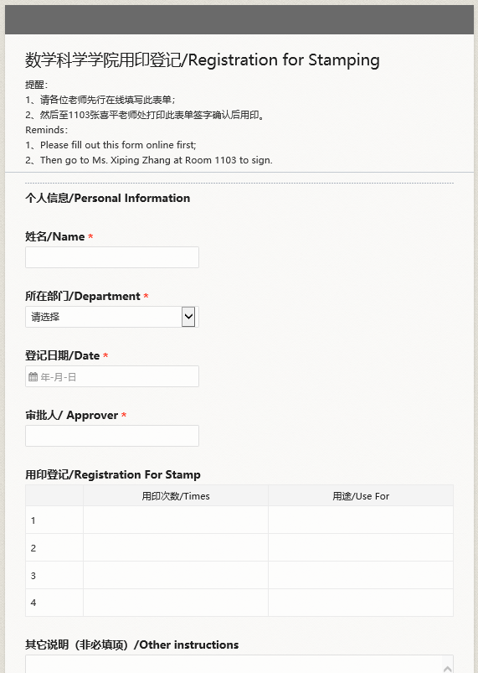

- Procedures for applying for stamping of financial seal
- Contact Limin Qin at the Administration Office (Room 712) for financial stamping;
- After operator, examiner and project leader attach their signatures and financial chief attaches his/her seal, contact Xiping Zhang in Room 103 to apply for stamping of the School’s official seal.
- The School’s official seal keeper preserves stamping record for future review by the University.

IV Discussion room and conference room
(contact for reservation: Jiajun Zhu; campus contact number: 622014; email: zhu_jiajun@sjtu.edu.cn)
Classroom Information
Classroom number | Board | Projection | Capacity
437 | whiteboard wall | Yes | 20
440 | whiteboard wall | Yes | 20
536 | whiteboard wall | Yes | 20
539 | whiteboard wall | Yes | 20
630 | blackboard | Yes | 30
639 | whiteboard wall | Yes | 20
813 | blackboard | not available | 40
Conference Room Information (hi-fi equipment not available)
Classroom number | Board | Projection | Capacity
703 | blackboard | Mobile projection | 50
706 | blackboard | Fixed projection | 60

- Online reservation of conference room and discussion room
1.1 Reservation website: Visit the School’s intranet management system
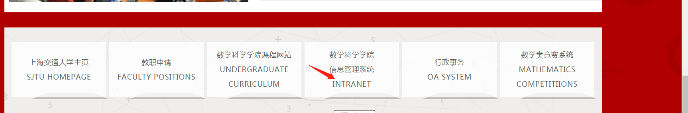
1.2 Click “Information Registration” for reservation registration
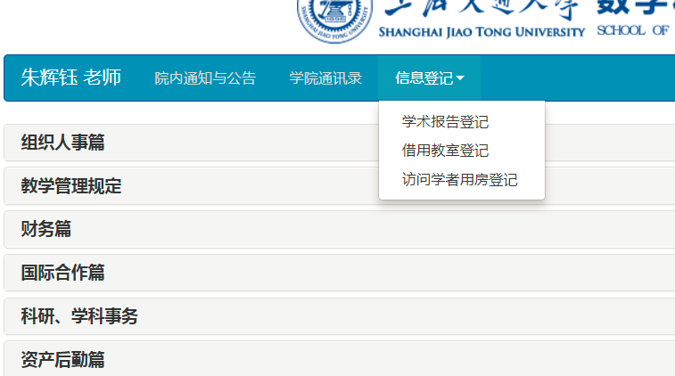

2 Cleaning of discussion room and conference room
Inform Ms.Hua (mobile phone:13917006679) after using discussion room or conference room and contact property management office for cleaning. Office supplies such as ink pen, chalk, blackboard eraser and wiping cloth can be obtained at the Administration Office before class (Contact: Hengmin Xu; campus contact number: 62212，hmxu@sjtu.edu.cn). Keep the office supplies in the classroom after using them.
Use cotton wiping cloth for cleaning writing wall in the classroom (437,440,536,539,639). Dampen the wiping cloth mildly for better effect.

ⅹ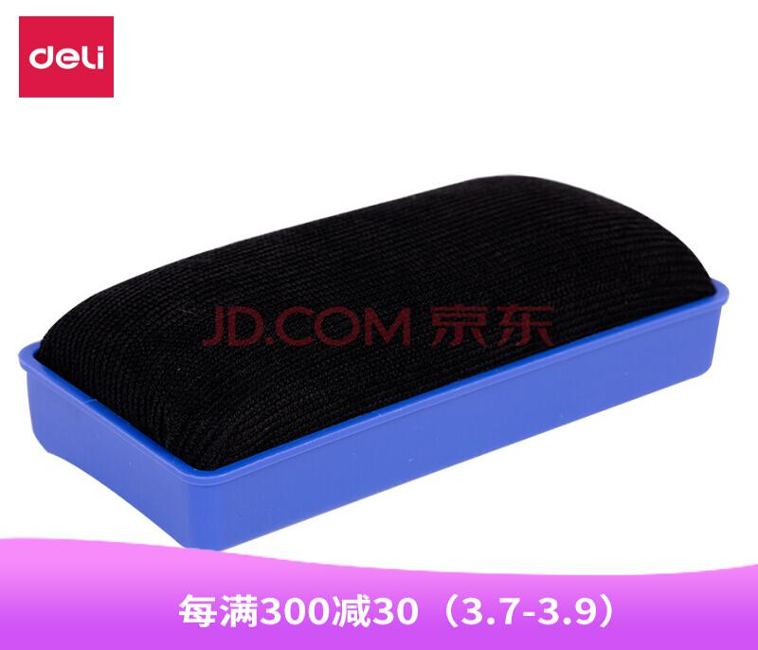
√

3 Mobile projection in discussion room
Please install Epson projection software on your laptop computer before using projector in the classroom. Just install the software once, your laptop computer can connect to mobile projector in any classroom. There is no need for a new installation.
1）Software installation (very simple; you may install it by yourself or ask help from staff of the laboratory)
Windows download: https://math.sjtu.edu.cn/d/epson_win.exe
Mac OS X download: https://math.sjtu.edu.cn/d/epson_MacOS.dmg
Installation on Windows: (Click “Confirm” or “Next”)
2）Using projector in classroom:
Turn on laptop computer and connect to WiFi network in the classroom. For example, choose WiFi signal of “room639”in Room639.
Important!!! Choose WiFi signal of the classroom you’re in; otherwise, you won’t find projector on your device or connect to projector of another classroom!
Activate projection software EasyMP Network Projection (under EPSON Projector). See picture below:
Choose Advanced Connection
Software will search for projector of the classroom. Selector the projector and click “Connect”.
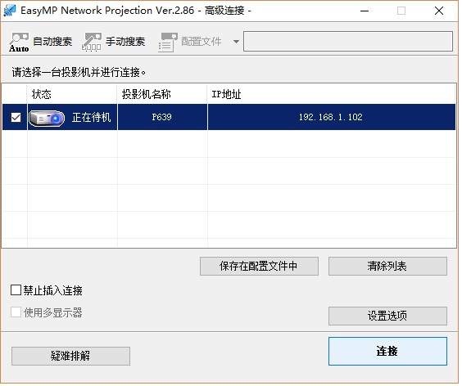
After connecting to projector, projector work bar will appear on the lower right corner of the screen. Use the work bar if needed.
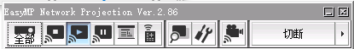
3）If there is still problem after the above steps or you want to borrow a laptop computer, please contact Xiaotong Jiang from the laboratory 728 (campus contact number: 62230，fate772yy@sjtu.edu.cn)
or contact Jiajun Zhu in Room 715 (campus contact number: 622014;13917006679).

V Visiting scholar office
Available visiting scholar offices are now on 4F/5F/7F (414, 420, 422, 434, 436, 520, 522, 538, 716 and 722). Rooms 436 and 538 can accommodate 3 people, and the other rooms can accommodate 2 people. See the following table for more information (availability is kept updated)
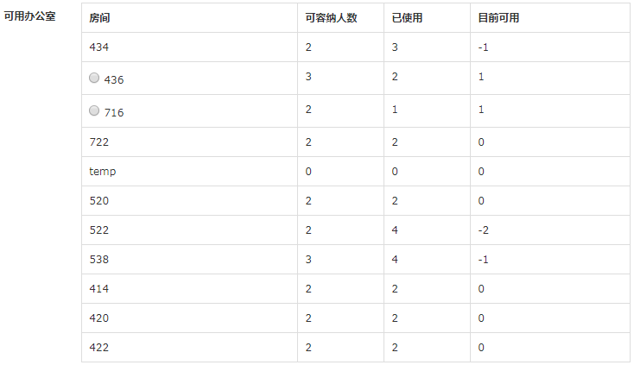

1 Reservation of visiting scholar office
1.1 Reservation website: visit the Intranet
1.2 Click “Information Registration” for reservation registration
(Contact: Jiajun Zhu; campus contact number: 622014, zhu_jiajun@sjtu.edu.cn）

2 Office supplies for visiting scholars
1) If visiting scholars want to apply for office supplies, please first submit application on https://jinshuju.net/f/CQRwfU and then go to Room 712 to receive the office supplies from Hengmin Xu. (campus contact number: 62212)
2) Please go to Room105 to receive visiting scholar office key from Ms..Hua (signing your name first) (Tel:13917006679).

VI School public printing facilities
1、Laboratory 728 offers technical services including printing and scanning. (Contact: Xiaotong Jiang; campus contact number: 62230)
2、For copying service (especially copy large quantities of documents), please go to room103 to ask help from Xiping Zhang who will offer copying service. Or you may go to the public area on 5/6F and use the internet connected printing (copying) equipment.
3、Internet connected printer (duplicator) is available in public area on 5/6F. If you have no printer in your office or you want to use the public printer, please contact staff from the laboratory and they will help you install driver on office computer or your personal laptop computer. You can start printing as needed. (Contacts: Xiaotong Jiang: campus contact number 62230; Xiaojun Liu: campus contact number 62220)

